Oval Accounting – Trial Guidance

The purpose of this document is to provide an overview of some of the key features within the Trial version of Oval Accounting. Further information and resources can be found on the website https://www.ovalaccounting.com/support/. If you require the trial period to be extended, please get in touch hello@ovalaccounting.com.

Oval Accounting – Trial Guidance 1
Introduction 2
Configuration 2
Entities 3
Financial Years 4
Chart of Accounts 5
Posting Rules and Schedules 6
Accounting 8
Transactions 8
Sales Invoice 9
Sales Payment 11
Recurring Journals 12
Revenue Recognition 14
Accounting Plans 15

Introduction

This document will take you through some of the key Configuration and Feature elements of Oval Accounting and Oval Administration within your Trial version of the product. The data displayed within the trial is purely for demonstration purposes.

Configuration

The configuration for Oval Accounting is setup within Oval Administration. You can access this by selecting Oval Administration from the ‘Search apps and items...’ dropdown.

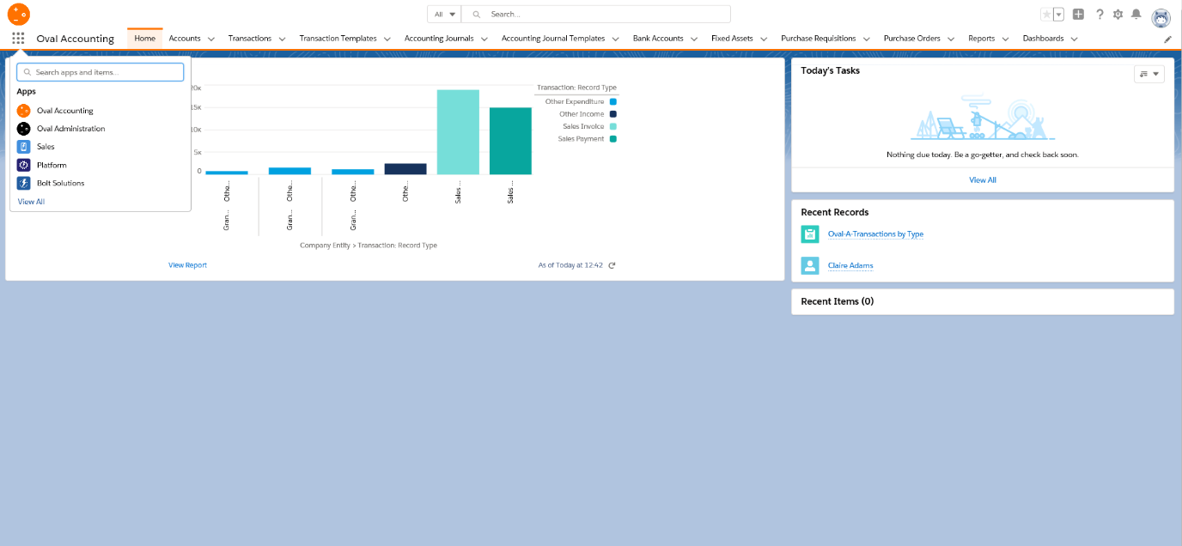

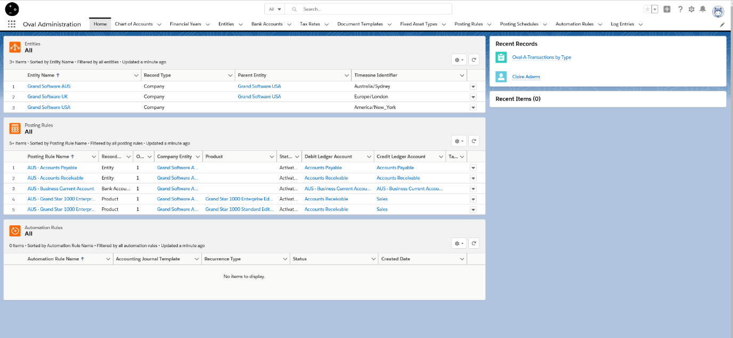
One point to note is that the non-trial version has an Accounting Helper which allows you to set the default entity to use, default Bank Account and Transaction notifications. Once this is set, you do not need to select the entity again across the product.

Entities

The first configuration feature to walk through is the Entities tab. This is where you can setup your Companies and also any Departments that are associated with these Companies.

When you click on the Entities tab within the trial, and select the list view ‘All’ you will see the Companies and Department setup by default for the purposes of the trial. To set your own up, you just click on the ‘New’ button. This will enable you to select the record type.

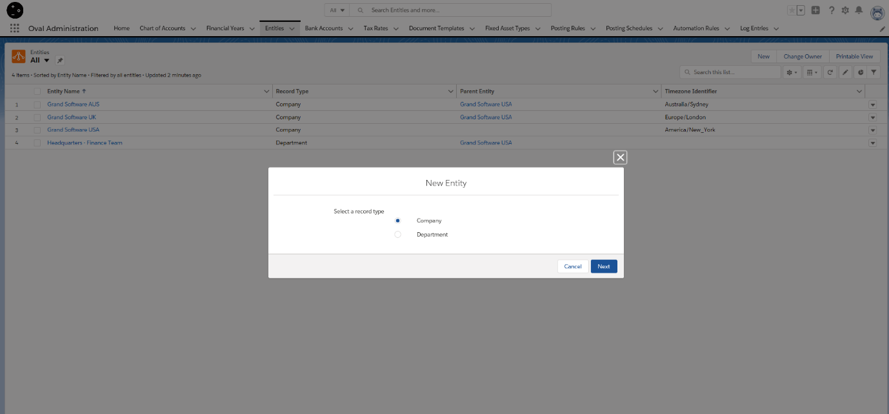
Clicking ‘Next’ will then display a more detailed form to complete the Company or Department details in full. From here you can also specify the ‘Time zone Identifier’ for the Company and the ‘Rounding Mode’ which is used when making calculations within Transactions. There is a Standard Chart of Accounts that comes with the trial and is a mandatory field.

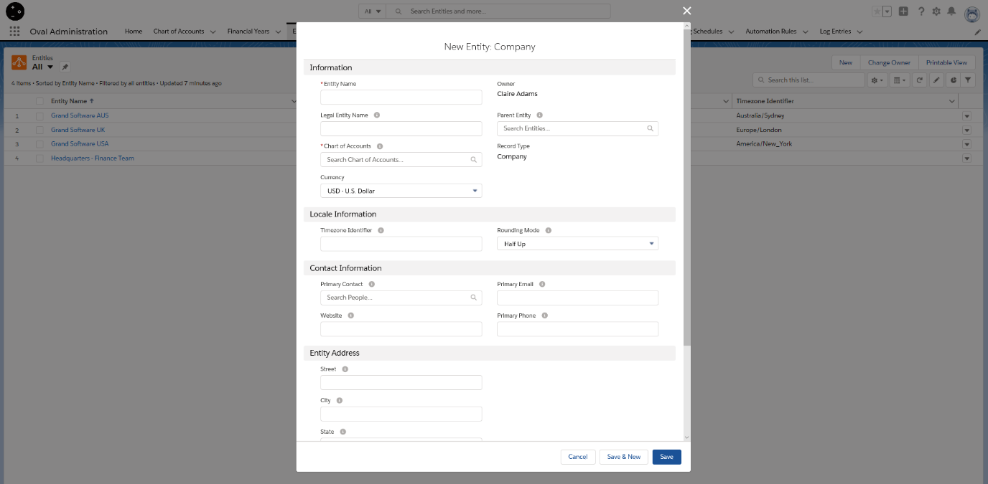
Once this has been setup, you can then associate a Financial Year to the Company or Department.

Financial Years

If you click on the Financial Years tab, list view ‘All’, you will see two financial years that have been setup as default for the trial. You can easily create new ones by clicking on the ‘New’ button.

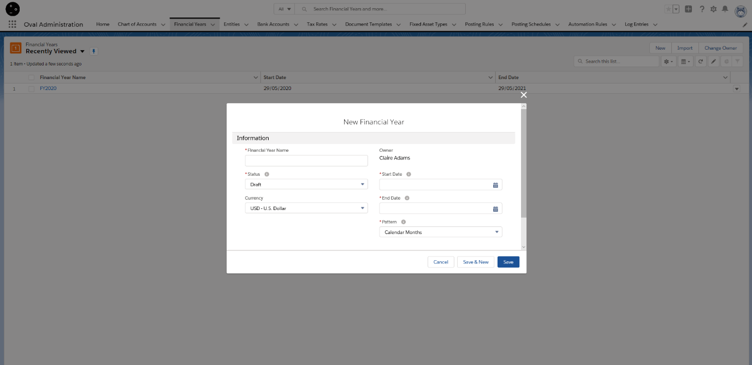

You can specify within here the Pattern for the Financial Year, so how Accounting Periods are generated. This can be by either Calendar Months, Calendar Quarters or 4 Calendar Weeks.

Once you save the Financial Year, the Accounting Periods are automatically generated. You can then set the Status to active.

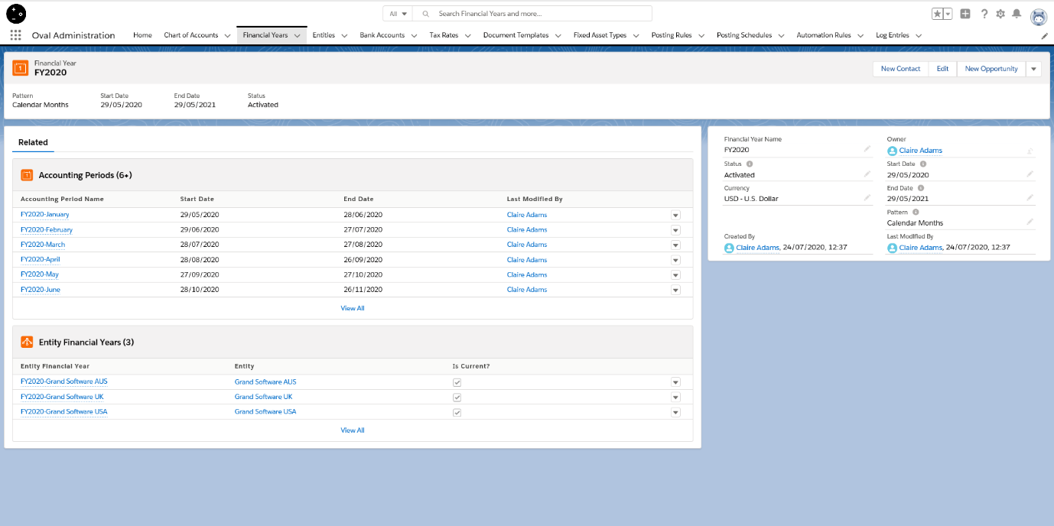
To associate a Financial Year to an Entity (Company or Department), if you click on the Entities tab, select an Entity, click on ‘New’ in the ‘Entity Financial Years’ section, from here you can search for the Financial Year and specify whether it is the current one to use for the Entity.

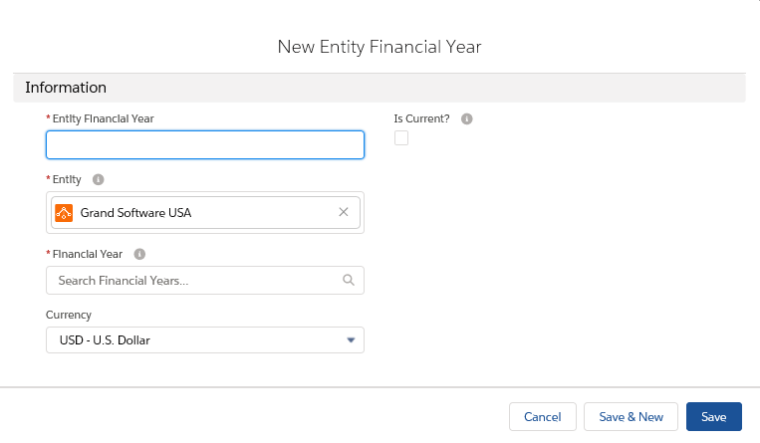

Chart of Accounts

The trial comes with a default set of Standard Chart of Accounts. If you click on the Chart of Accounts tab, and select ‘All’ from the list view, the Standard Chart of Accounts is listed. Click this and you will see the Ledger Accounts and the Ledger Account types that are associated with this COA.

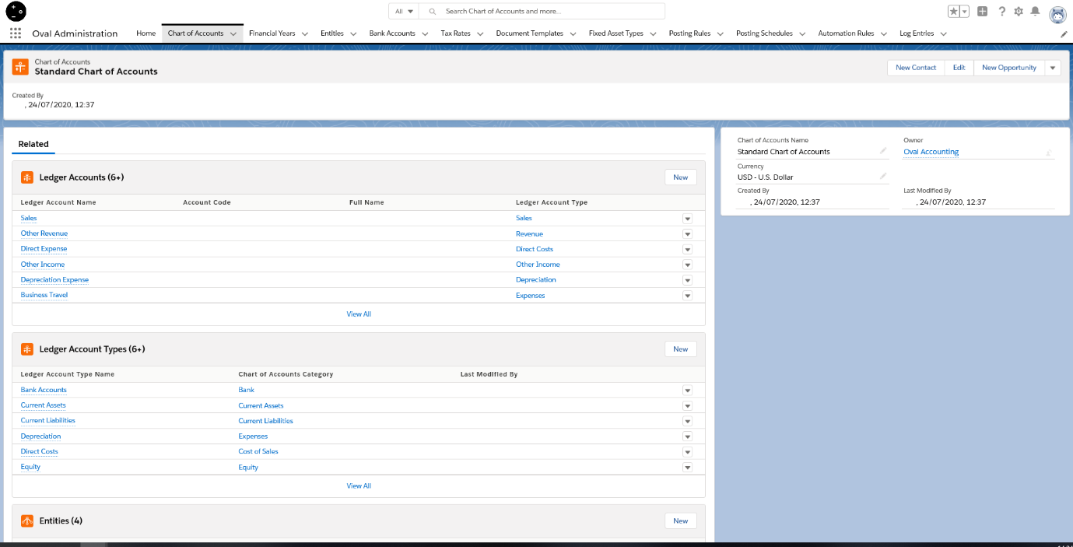
You can add new Ledger Accounts and Ledger Account types by clicking on the relevant ‘New’ button.
You can also create your own independent Chart of Accounts from the main COA tab, and selecting the ‘New’ button.

Posting Rules and Schedules

Posting Rules link transactional records with the Chart of Account. If you select ‘All’ from the list view within the Posting Rules tab, you will see a list of all Posting Rules that have been provided by default for the trial.

If you click on the ‘New’ button, you will see that there are 6 different Posting Rule types for you to select and setup a rule for.

Bank Reconciliation allows you to create rules for how bank transactions are automatically reconciled. You can specify an Account the rule applies to, the Bank Account, filter on a reference and state the amounts from and to. You can also specify the dates that the transaction occurs between.

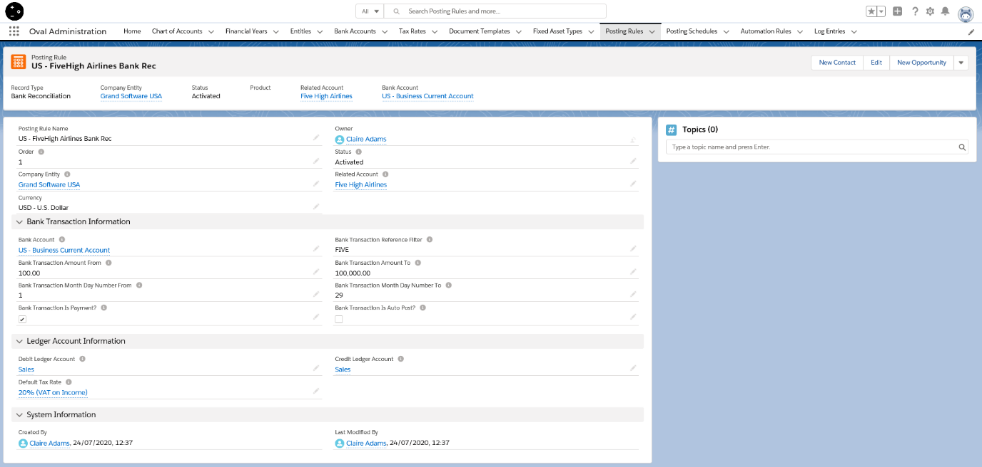

Products allows you to setup a posting Rule for a specific Product. You can specify the Transaction Type the rule applies to, the individual Product, and which Ledger Accounts should be credited and debited.

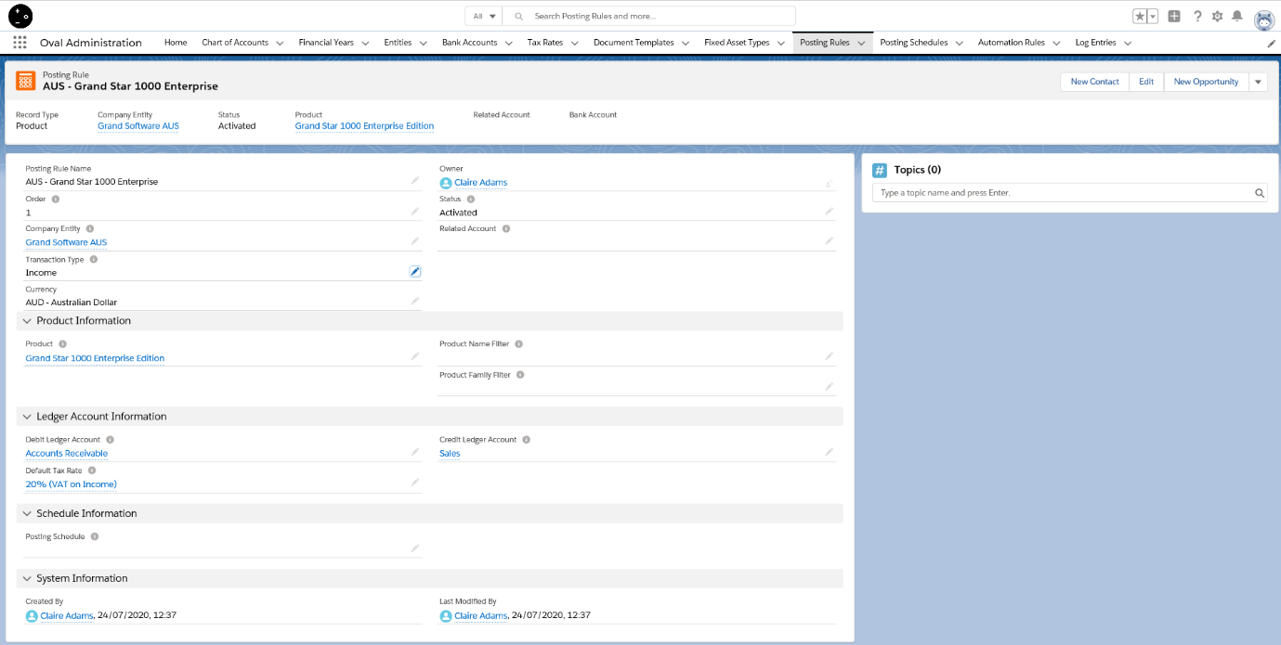
Entity Posting Rules allow you to specify key accounts in the Chart of Account. You can setup a Posting Rule for Accounts Payable or Accounts Receivable.

You can also view Posting Schedules.

If you click on the Posting Schedule tab and select ‘All’ from the list view, you will see an example of a Posting Schedule has been provided as part of the trial.

You can specify when the Posting Schedule should run, the percentage of the net amount that should be posted and the ledger accounts that it applies to. As you can see in the example provided, the schedule applies to 3 different Product Posting Rules.

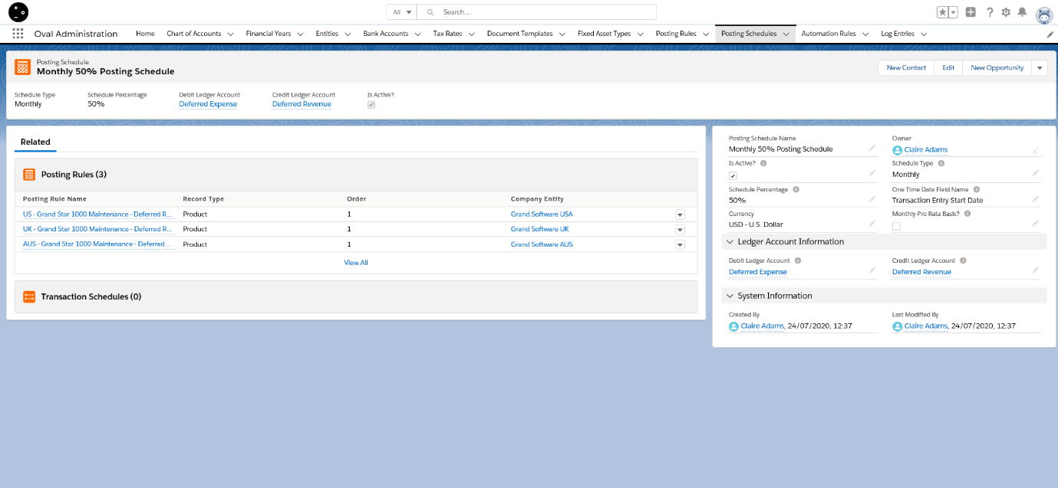

Accounting

The core Accounting Features can be found in Oval Accounting which you can access from the ‘Search apps and items...’ dropdown.

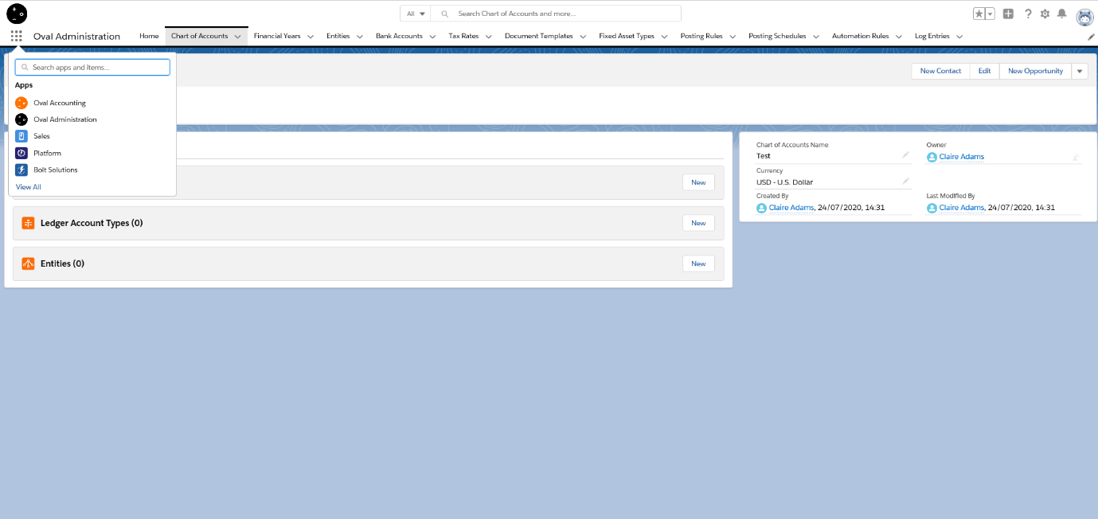

Transactions

The Transactions tab is where you can create the following Transaction types:

Sales Invoice
Other Expenditure
Other Income
Purchase Invoice
Purchase Payment
Sales Payment

If you select ‘All’ from the list view, you will see a list of Transactions provided by default for the trial.

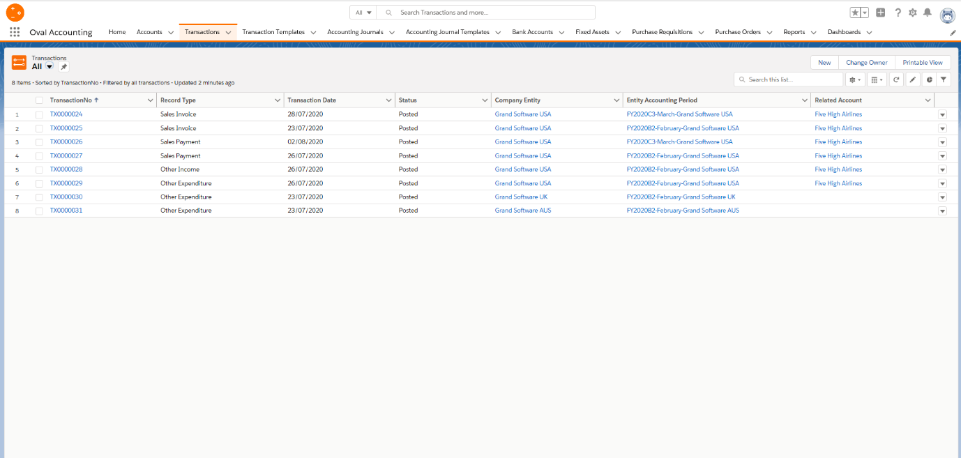

Sales Invoice

To create a Sales Invoice, click on the ‘New’ button. From here you can see that the Sales Invoice is selected by default so you just need to click ‘Next’.

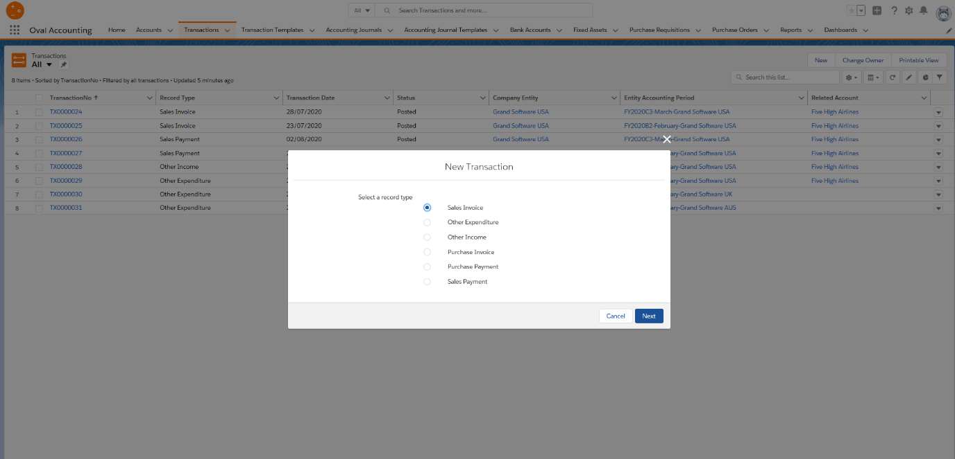
Clicking the ‘Next’ button will take you to the New Transaction form. At this point, the minimum you need to input is the date of the Transaction, but we will also select an Account it relates to (Five High Airlines) and then save.
From here you can then enter the Transaction entries (line items).

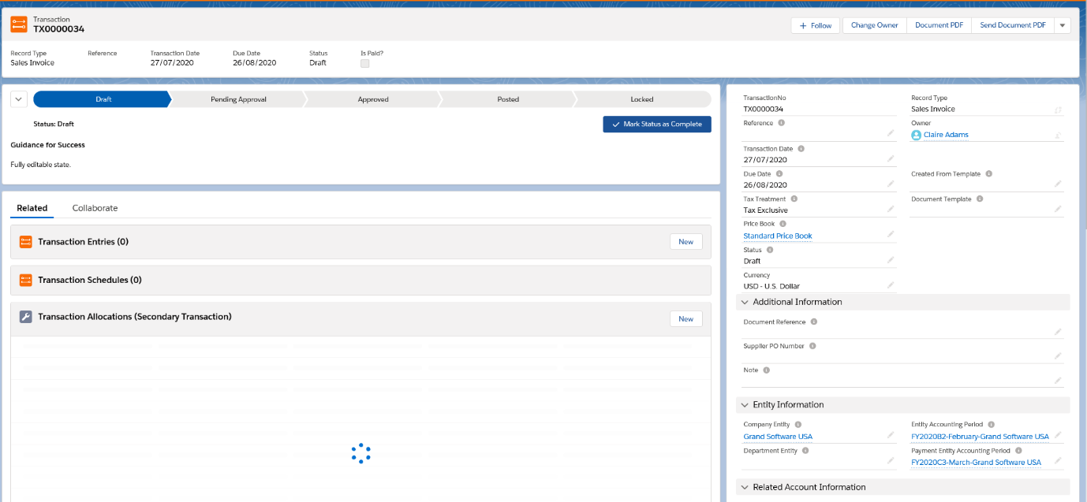

Click on the ‘New’ button. To demonstrate how the Posting Rules, work for Products, select a Product which has a rule setup, for example ‘Grand Star 1000 Enterprise Edition’ and then click on save. You will see that all the details for this product have been populated, based upon the Posting Rule which has been setup for it.

In order to post the transaction, you can do this by changing the status field, or you can do so via a Kanban bar. To set this up in the trial, follow these steps:

- Click on setup.
- Search for Path Settings.
- Click on Enable.
- Tick the checkbox.

When you go back to the transaction you will then see a bar with different statuses. Click on ‘Posted’ and ‘Mark as Current Status’.

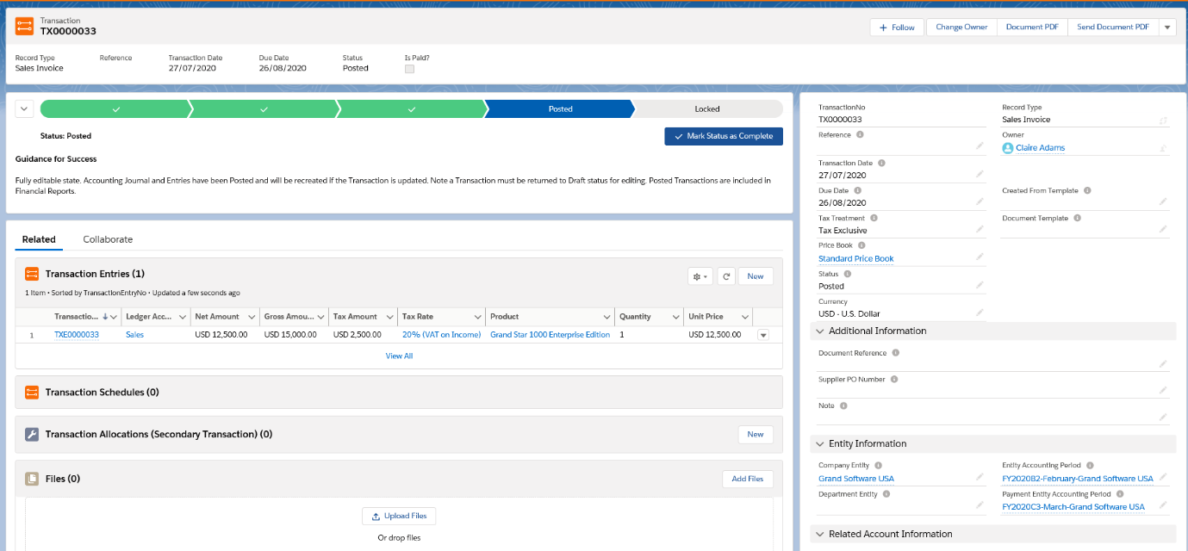

If you go to the Account this transaction related to, ‘Five High Airlines’, you will see that there is a summary of the Transactions associated with the Account. Please note, in the trial version you will need to go to the Account Object Page layout to add the Transactions section. To do this, follow these steps:

- Click on Setup.
- Go to the Object Manager.
- Select Account.
- Select Page Layouts.
- Select Account Layout.
- Select Related Lists.
- Select Transactions and drag onto the Related Lists section.
- Click on Save.

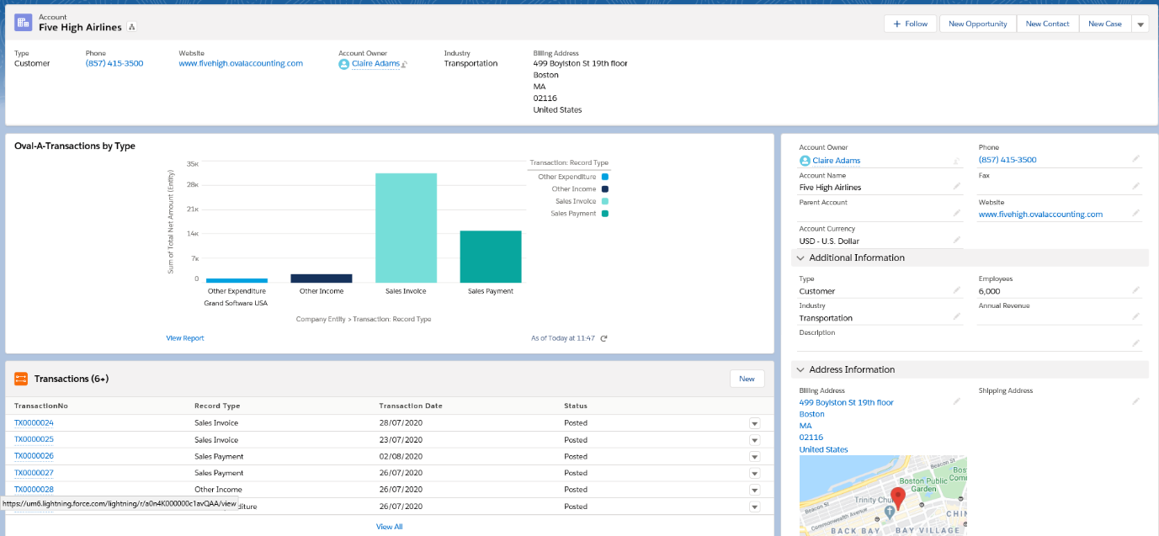

Sales Payment

To create a Sales Payment, click the ‘New’ button in Transactions and select the record type ‘Sales Payment’

Once you click ‘Next’ a form will be displayed for you to complete. As a minimum, you can enter the following details:

Ledger Account
Tax Rate
Unit Price
Net Amount

When you click ‘Save’, and then click into the Transaction Entry, you will see the Financial Fields have been populated for you.

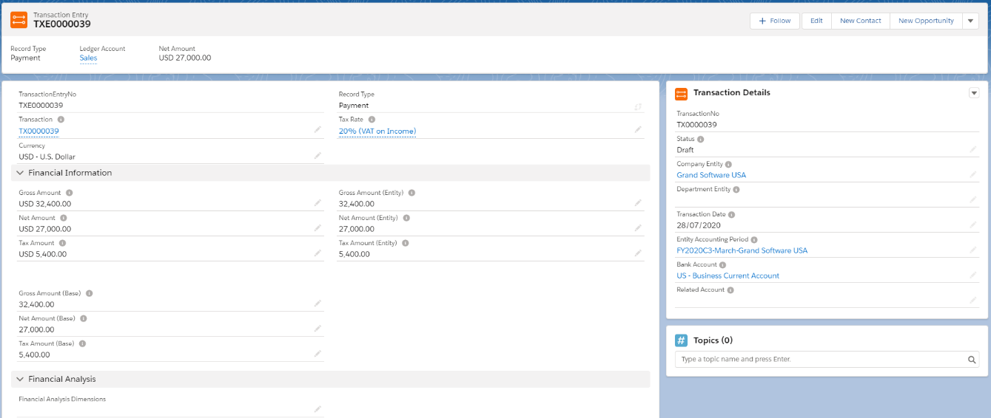

You can then add a Transaction Allocation which effectively links this payment to an Invoice (Secondary Transaction).

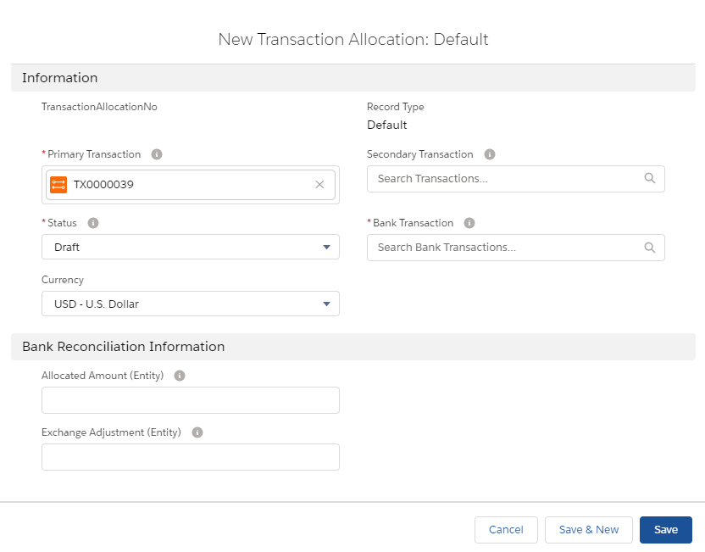
The sequence of events for a Sales Invoice and Sales Payment would be to create the Sales Invoice, then create the Sales Payment and then Allocate the payment to the Sales Invoice.

Recurring Journals

You can setup Recurring Accounting Journals by creating an Accounting Journal Template. Click on the Tab and click on the ‘New’ button. The New Accounting Journal template form is displayed and defaults to ‘Standard’. Click on the ‘Next’ button and a form is displayed for you to complete.

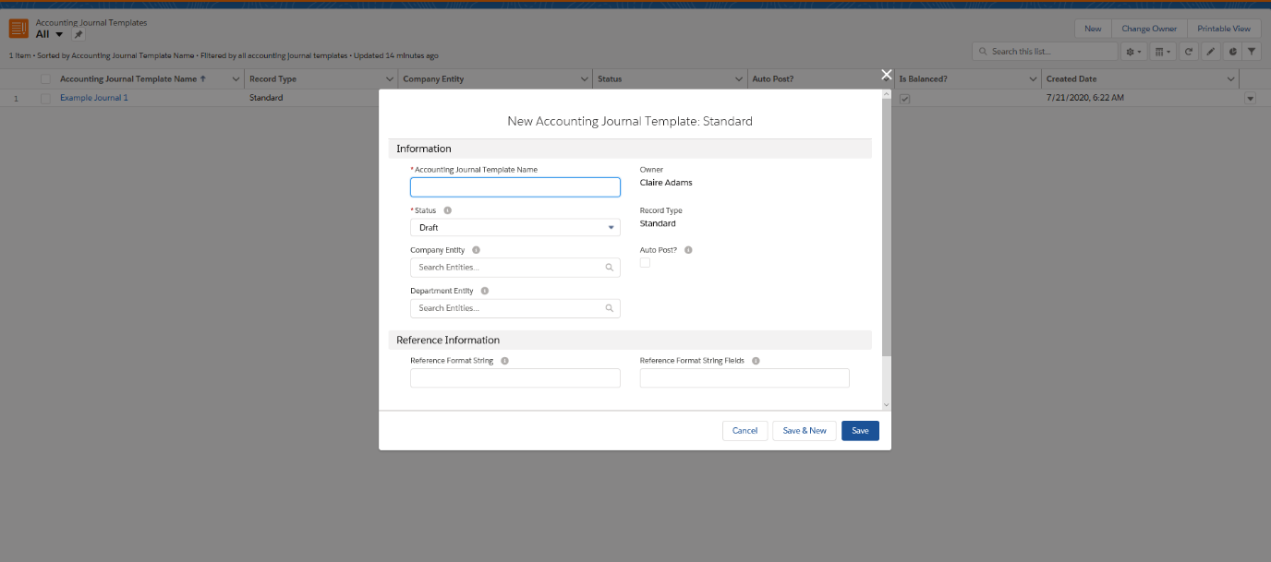
Give the Accounting Journal Template a name, search for the Company Entity, tick the ‘Auto Post?’ checkbox and then click save.

From here you can now add Accounting Entries by clicking on the ‘New’ button and enter the debit or credit amount and the Ledger Account. Create another so that the journal balances and change the status to Activated.

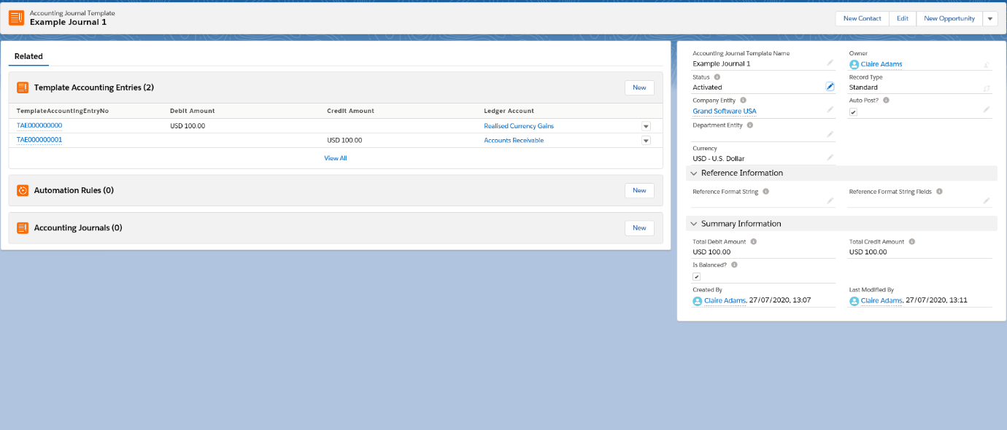
You can now setup an automation rule which will run on the specified time and date to post the Journal entries.

Click on the ‘New’ button. Within this form you can add the date, time, day and recurrence type.

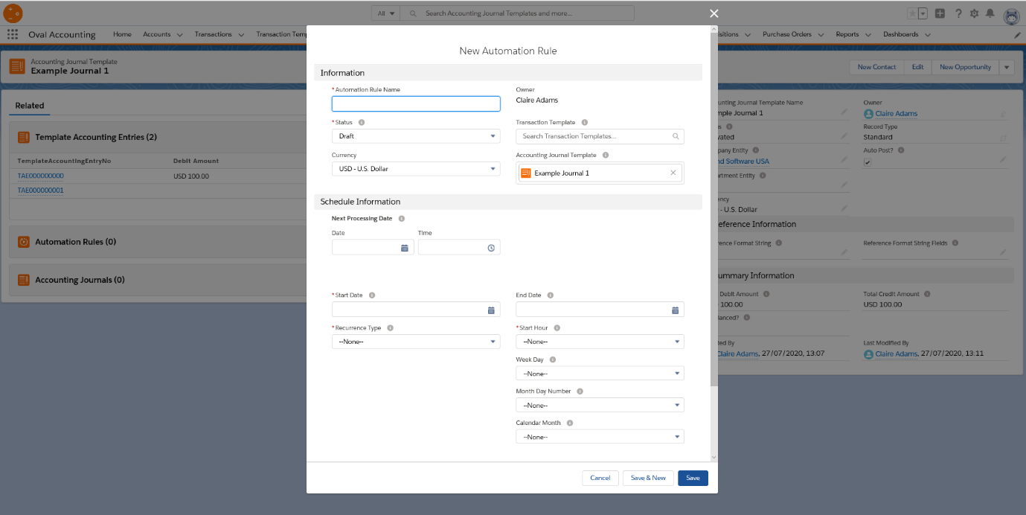
Once you have activated, the automation rule will run automatically using the dates and times specified.

Revenue Recognition

Within the Posting Rules there are some examples for deferred revenue. These are linked to the product ‘Grand Star 1000 Maintenance’ and uses the example posting schedule ‘Monthly 50% Posting Schedule’.

If you navigate to the Transactions Tab, you can create a Sales Invoice using the ‘Grand Star Maintenance’ product and then save. Ensure the Schedule start and end dates are completed and then save. Mark the current status of the Transaction to ‘Posted’.

You will see that the Transaction Schedule has been setup and if you click into it you will be able to see the entries to be made at the schedule time specified.

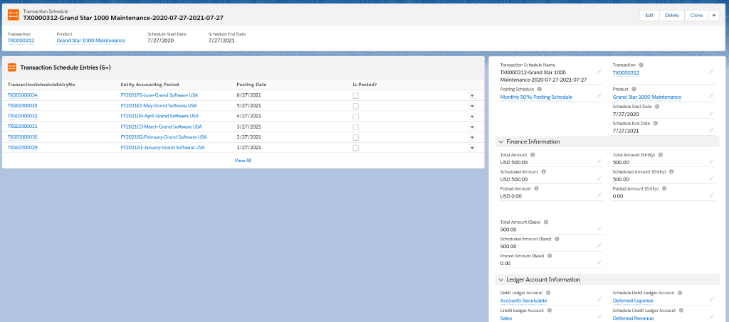

Accounting Plans

If you click on the Accounting Plans tab and select ‘All’ from the list view, you will see an example of an Accounting plan provided with the trial. Accounting Plans are there to support the definition and tracking of Financial Strategies. They are used for providing Financial Performance Management Tools.

If you click into the plan you will see that they can be setup for Measures and Key Dates. Measures are used to track performance management whilst Key Dates are used for compliance management, for example when a Tax return is due.
